FOR IMMEDIATE RELEASE



Safeguard Now Offers Direct Gritting
Hi-Traction anti-slip surface applied directly to your truck or vehicle parts

STREETSBORO, Ohio – (July 29, 2010) – Safeguard Technology, leading innovator of anti-slip solutions, offers Direct Gritting to prefabricated truck parts, including truck steps, bus ramps, trim assemblies and all vehicle access areas that pose a potential risk for slips and falls.

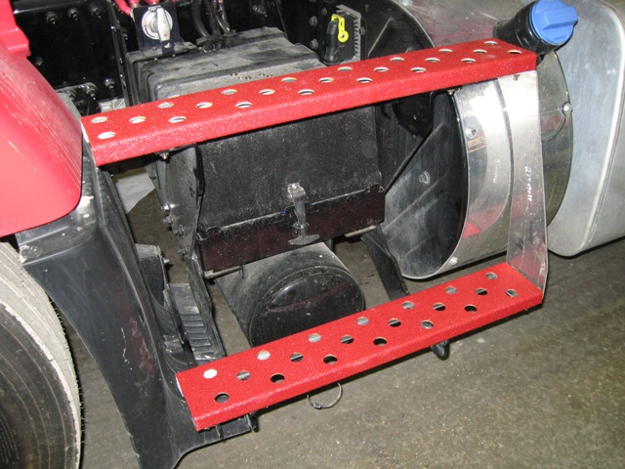
Traditionally, manufacturers and end-users install retrofit covers either mechanically, or by using an adhesive. Retrofit covers are also the route to take when installing an anti-slip solution on existing fleets in the field.

With Direct Gritting, customers supply their parts (or an engineered drawing for fabrication) and Safeguard applies its Hi-Traction anti-slip surface directly to the specified area. Direct Gritting helps reduce installation time, weight and the need to stock extra parts; thus reducing cost. It is a desirable alternative when aesthetics are important or when mechanical fasteners are not an option (either structurally or due to unsightly screw heads).
Direct Gritting on steps in customer-specified color
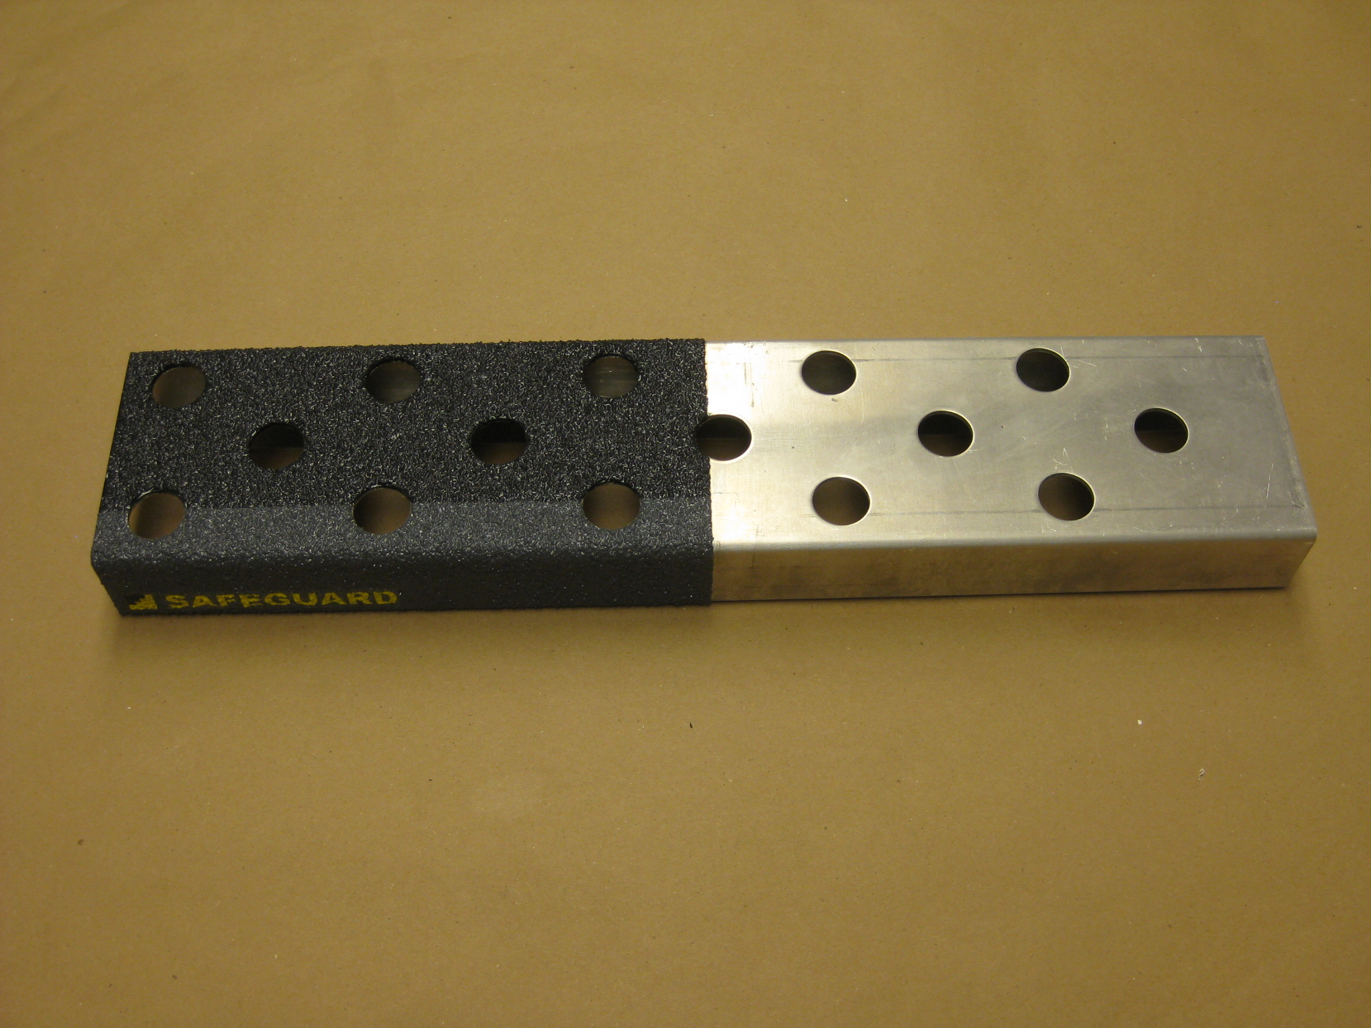
“There is a common misconception that diamond plate is an antislip solution,” explains Erick Schuetz, Safeguard Technology manager of sales and marketing. “Diamond plate looks great on the side of a fire truck in a parade, but it offers little-to-no slip resistance. If you introduce water or oil, diamond plate becomes treacherous. Direct Gritting precludes the need for diamond plate by substituting flat steel. It saves material costs while providing the highest quality anti-slip surface on the market.”

Direct Gritting Before
-more-

Direct Gritting is available in all of Safeguard’s standard and premium colors, as well as Photoluminescent “Glow-in-the-Dark” and custom color matches. With Direct Gritting, customers can combine colors for a two-tone configuration; incorporate custom messaging, logos and PPE (personal protective equipment) symbols; and choose from a variety of grit levels to meet their application requirements.

Direct Gritting is ideal for industrial and transportation applications, and can be applied to many surfaces, including:
- Work truck steps
- Bus trim parts
- Bus ramp
- Metal stair treads
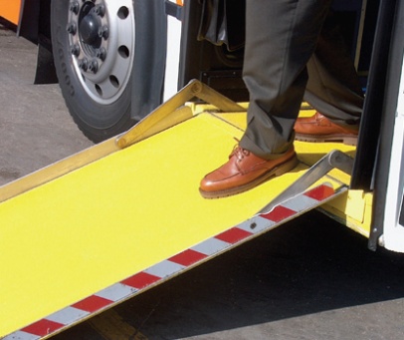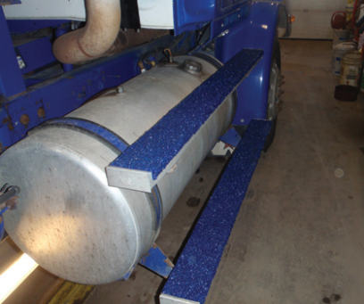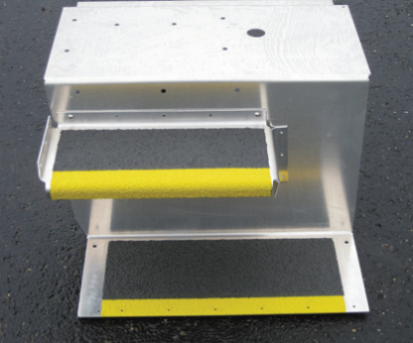
Safeguard has been Direct Gritting since its inception in 1992. For more information about Safeguard’s Direct Gritting and other anti-slip solutions, visit them online at www.safeguard-technology.com.

About Safeguard Technology:
Safeguard Technology, headquartered in Streetsboro, Ohio, is a leading innovator in the safety industry, and is dedicated to the design, development and manufacture of superior safety products for the prevention of slips and falls. Safeguard® Covers are utilized worldwide and have been considered to be the first choice for application in the offshore oil and gas industry.

For product questions, contact Safeguard Technology Customer Service at 1-800-989-1695 or visit www.safeguard-technology.com. Downloadable press releases and images are available on Safeguard’s online news archive at www.editorpressroom.com/safeguard.

Contact:
Erick Schuetz
Safeguard Technology
330-995-5200 ext. 222
erschuetz@safeguard-technology.com

Abbey Linville
Crowl, Montgomery & Clark
330-494-6999 ext. 207
alinville@crowlinc.com

###

